Webflicks Report
By Arpa Banik

This report evaluates the impact of TV show release models and genres on viewership for Webflicks, aiming to identify whether a particular release style or genre influences viewer behavior compared to the current model. The current model, “Drop,” involves releasing an entire season at once. Two alternative models were analyzed: “Weekly,” where episodes are released weekly, and “Dual-Drop,” where the season is split into two parts, with each part released separately. The primary genres considered were Comedy, Drama, Mystery, and Fantasy. Understanding viewer preferences is critical for enhancing Webflicks' viewership. Based on the analysis, the “Drop” release model consistently resulted in higher viewership, with an average increase of 8.6 minutes compared to other models. It is recommended that Webflicks retain the “Drop” model for all genres due to its demonstrated effectiveness in boosting engagement.

The experiment included a sample of 180 shows. A power analysis was conducted to determine the appropriate sample size required to produce statistically reliable results. For release models, 168 shows were needed, while 192 shows were necessary for genre comparisons. Consequently, the given sample size was sufficient to analyze release models but not large enough for conclusive genre-based comparisons. The experiment proceeded with 180 shows to get as close as possible to the recommended sample sizes for both factors.
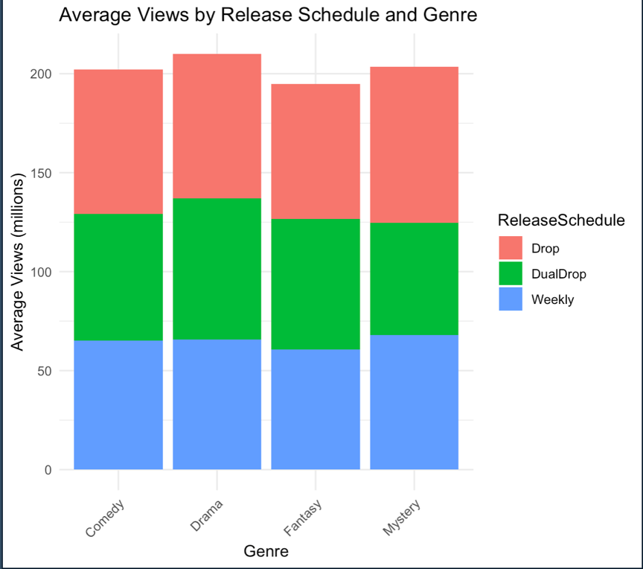
A boxplot analysis revealed that the “Drop” release model consistently accounted for the largest share of viewership across all genres, indicating a strong preference for binge-worthy content regardless of genre. Furthermore, the overall average viewership appeared consistent across genres, suggesting no significant differences in popularity.
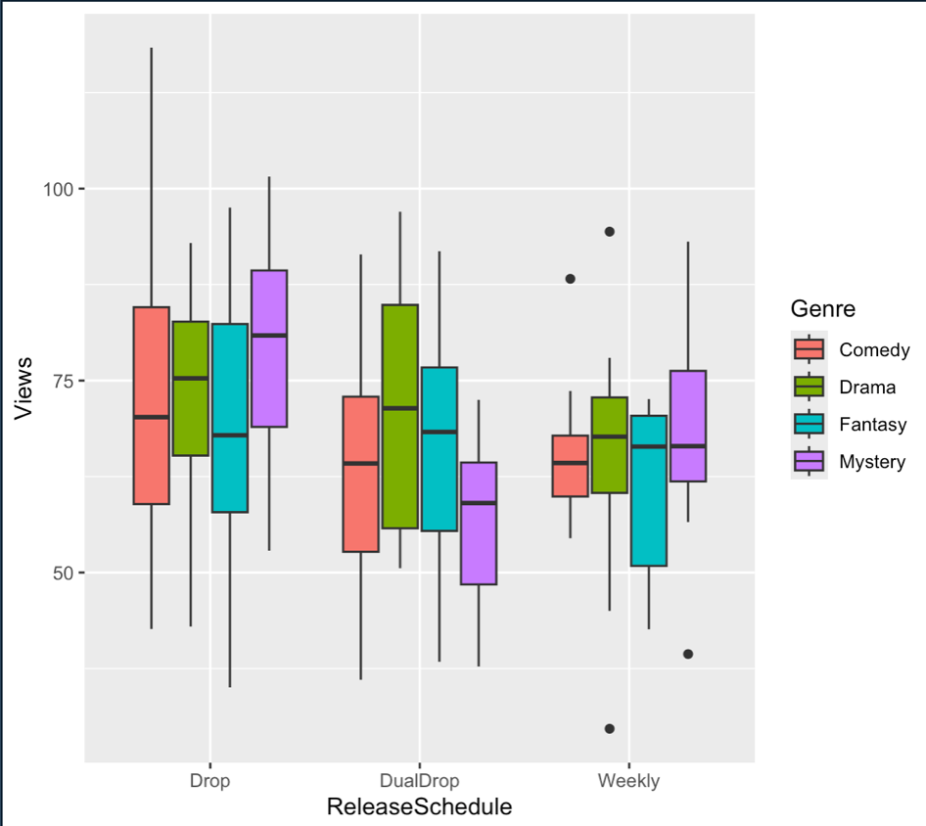
View times were recorded for each show and categorized by release model and genre. These results were grouped into release-genre pairings and analyzed for differences in viewership. The boxplot above visualizes the differences in average viewing time for each of these pairings. While genre had minimal impact, there was a clear trend of increased view times associated with the “Drop” release model compared to the “Weekly” and “Dual-Drop” alternatives.

To systematically study the relationship between release models, genres, and their impact on viewership, a statistical ANOVA test was conducted to evaluate the differences in average view times. The findings confirmed that at least one release schedule model differed significantly in terms of average viewing time. The “Drop” model exhibited the highest average view time at approximately 73 minutes. In contrast, there was no evidence that genre had a significant effect on viewership.
Release Schedule Model | Average View Time
Drop | 73.27 minutes
Weekly | 64.45 minutes
Dual-Drop | 64.88 minutes

The test results indicated a statistically significant difference in viewership across release models (p -value = 0.00163), with the "Drop" model outperforming the other models in terms of average view time. In contrast, the analysis revealed no significant differences across genres (p -value= 0.46763). The test with full output is available in the appendix

Combining the information from the ANOVA analysis, post-hoc analysis, and visualizations above, it is highly recommended that Webflicks continue utilizing the “Drop” model across all genres to maximize viewership and support the platform's long-term success. Additionally, it is noted that there is no statistically significant evidence that genre affects view times. Finally, the study acknowledges a key limitation in that the desired statistical power could not be achieved for the Genre factor, though the power that was achieved (79.90%) was fairly close to the desired 80%, so this limitation is fairly minimal. While the study highlights the importance of release schedules in influencing viewer behavior, further investigations are needed to explore additional factors, such as audience demographics, show popularity, or platform-specific dynamics, which could further refine Webflicks' content strategy.

Appendix

Figure 1 – Summary Statistics
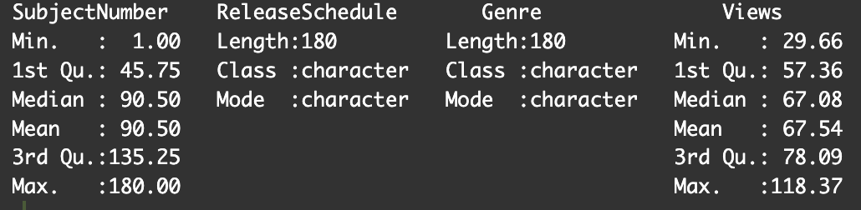
This figure shows the summary statistics of the variables in the dataset.

Figure 2 – Residual Q-Q Plot
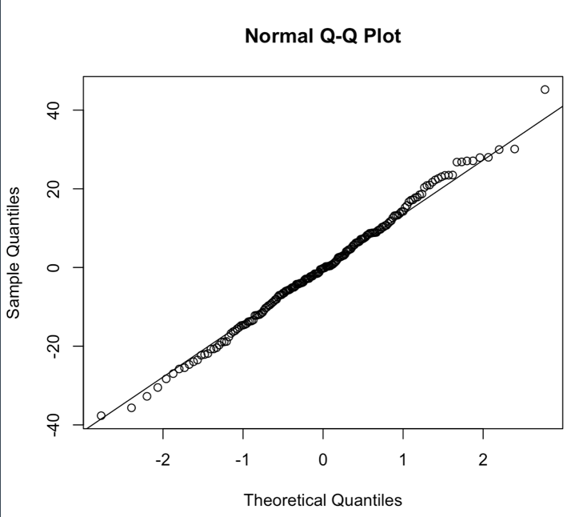
This figure depicts the Q-Q Plot of the residual values. It shows a fairly straight line, indicating that the population of the residuals is approximately normally distributed, and so we can proceed with our Two-Way ANOVA analysis.

Figure 3 – Residuals vs. Predicted Values Plot
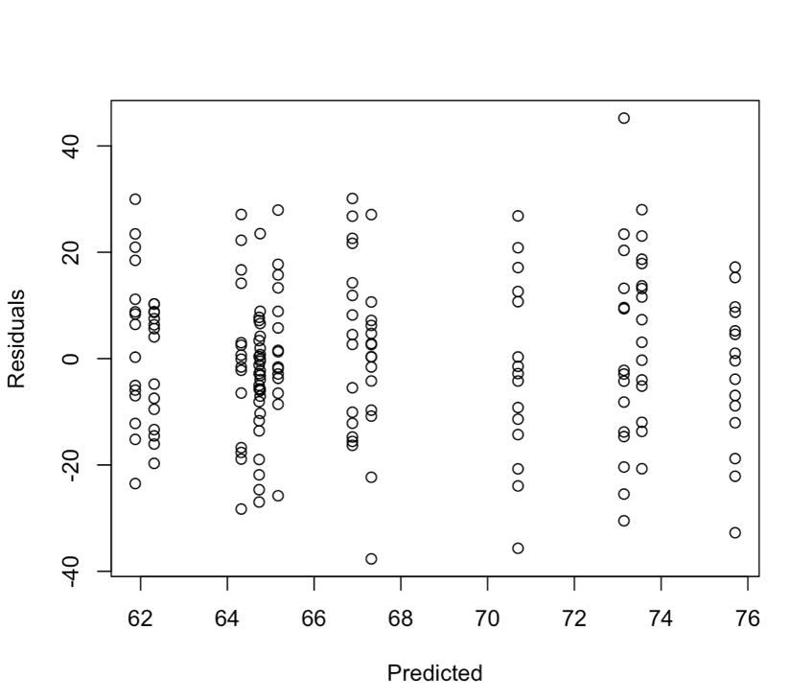
This figure depicts the Residual vs Predicted Values Plot for the data. From this plot we see a consistent spread in the residuals, which indicates that the homogeneity assumption is likely reasonable for our Two-Way ANOVA analysis.

Figure 4 – ANOVA Test Output
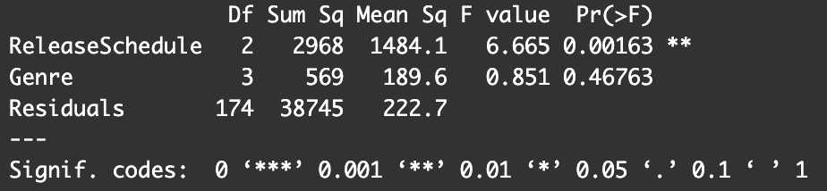
From this output, we see that the p-value for the ReleaseSchedule factor is 0.00163, while the p-value for the Genre factor is 0.46763. For the ReleaseSchedule factor, the p-value is less than the 5% significance level, leading us to reject the null hypothesis that there is no difference in view times across the release schedule models. Therefore, there is evidence that at least one of the release schedule models has a statistically significant difference in its impact on view times.
For the Genre factor, the p-value is greater than the 5% significance level, so we fail to reject the null hypothesis. This indicates that there is no statistically significant evidence that genre affects view times. Since there is evidence of a statistically significant difference among release schedules, a post-hoc test was conducted (pairwise comparisons) with a Bonferroni correction, to identify which specific release models differ and are most effective.

Figure 5 – Pairwise Test Outputs
5.1 – Drop and Weekly
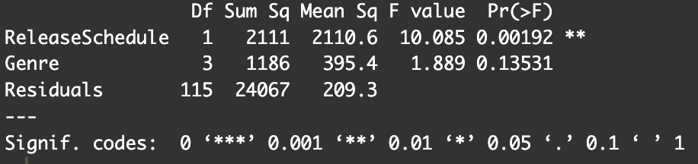
5.2 – Drop and Dual-Drop
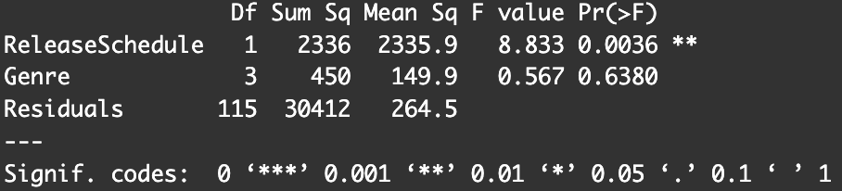
5.3 – Weekly and Dual-Drop
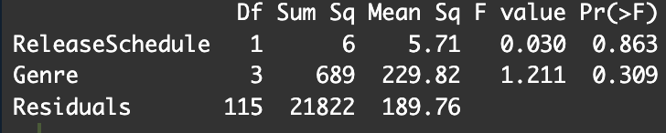

The figures above depict the outputs for the pairwise tests and applies the appropriate Bonferroni corrections to the p-values. At the 5% significance level, there is evidence that the Drop release model is different from the Weekly and Dual-Drop models.

Figure 5 – Average summary for Release Schedule and Genre Pairings
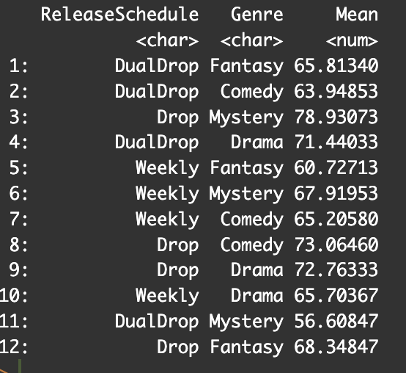
The table displays the mean view times for each combination of release schedule and genre. The Drop release schedule consistently shows higher average view times across all genres.

